

Le Page Architects Ltd
Studio 2
Plumer House
Tailyour Road
Plymouth
Devon
PL6 5DH

E enquiries@lepagearchitects.com
T +44 (0) 1752 849 880

Written by: SCr
Issue Number: 1
Date: 17/04/2026

Compliant with the Construction (Design and Management) Regulations 2015
Pre-Construction Information
J26/014 Betsy Grimbal and Still House Towers, Tavistock, Grant Funded fabric restoration, consolidation and Repairs
Contents
1.0 Issue Register 2
2.0 Introduction 3
3.0 Project Description 4
3.1 Project Description and Programme 4
Nature of Construction Work 4
Period for Construction Work 4
3.2 Project Team 5
3.3 Usage 6
3.4 Details of existing records and Plans 6
Existing Services Details 6
4.0 Clients Considerations and Management Requirements 7
4.1 Arrangements 7
4.1 Client Considerations 7
4.2 Design Safety Management 7
4.3 Site Management and Organisation 7
4.3 Specific Site Rules 8
5.0 Environmental Restrictions and Existing On-Site Risks 9
6.0 Significant Design and Construction Hazards 11
6.1 Hazards 11
a) Access to the Site 11
b) Existing Building 11
c) Existing services 11
d) Working at Heights 11
e) Fire & Emergencies 11
f) Client Personnel/Client Authorised Consultants/Visitors 11
6.2 Method Statements 12
7.0 Health and Safety File 13
8.0 Appendix
Utility underground service locations: 1. South West Water 2. Wales and West Gas, National grid electrical power.

Issue Register
Issue no. | Distribution | Date
1 | Issued for tender | April 2026

2.0 Introduction
The Construction (Design & Management) Regulations 2015 require that suitably adequate documentation, in a live and active format is produced as two separate entities, that will ensure the health, safety and welfare of all persons involved with the construction and subsequent usage of a building.
This pre-construction document describes the project, construction works and timing, identifies unusual hazards and risks, including interfacing activities and the required standards for health, safety and welfare.
The Information contained within the pre-construction document will be updated to incorporate information and any further hazards identified by the designers during the period of the works.
The Principal Contractor will develop the information contained within the pre-construction document into the construction phase health and safety plan, incorporating their programme, method statements and detailed arrangements demonstrating their management of construction, site safety and training.
Under the CDM Regulations 2015, a client is not to permit commencement of construction activities without the construction phase health and safety plan being in place, together with all necessary welfare facilities.
Similarly, the CDM Regulations 2015 require the Principal Designer, (who has undertaken CDM Co-ordinator functions throughout the pre-construction stage) to transfer all associated documentation to the Principal Contractor, who immediately following their appointment will implement CDM Co-ordinator duties and responsibilities for the remainder of the Project. In addition, he continues to undertake the duties required by CDM Regs 2015 to develop the details contained within the pre-construction document to take account of the following:
- Their proposed designs by their Specialist Sub-contractors in compliance with CDM Regulations 2015 and all current legislation, and subsequently agreed by the Principal Designer
- Any changes to the design proposed by the Client by agreement with the Principal Designer and Clients in compliance with CDM Regulations 2015
- All aspects of Health & Safety relevant to the Contractors method of working
- Detailed Health and Safety procedures of all their Contractors
- All current relevant legislation
Throughout the project, the documentation for the Health and Safety File will be prepared by the Principal Designer. The Principal Contractor will provide the Principal Designer with the necessary information, for collation and use in the compilation of the Health and Safety File and subsequent handover to the client.
This Health & Safety File will contain all health and safety records, and information relating to the project, including information on the design, materials and construction and 'As Built' records and test certificates and operating and maintenance manuals.

3.0 Project Description

3.1 Project Description and Programme
Location: Betsy Grimbal Tower
Plymouth Road
Tavistock
PL19 8AY

SX 48110 74332
What3words snail.doing.person

AND

Still House Tower
Riverside Walk
Tavistock

SX 48159 74261
What3words dairy.from.healers

Nature of Construction Work
- Provision and use of suitable work at height access equipment
- Masonry repairs to external walls
- Formation and installation of new ferrous guarding on site.

Period for Construction Work
Period for Construction Works | Approximately 21 weeks
Mobilisation Period | To be agreed
Site Works Commencement Date | End June 2026
Practical Completion Date | 20th Nov 2026

3.2 Project Team
Discipline | Name | Contact | Tel. No.
The Client | Tavistock Town Council | Wayne Southall  wayne.southall@tavistock.gov.uk | 07714 222341
The Architect | Le Page Architects  Plumer House  Tailyour Road  Plymouth  PL6 5DH | Simon Crosbie MA Arch Cons  scrosbie@lepagearchitects.com  enquiries@lepagearchitects.com | 07825  092843
The Principal Designer | Le Page Architects  Plumer House  Tailyour Road  Plymouth  PL6 5DH | Simon Crosbie  scrosbie@lepagearchitects.com  enquiries@lepagearchitects.com | 01752 849880
The Principal Contractor | TBC | TBC | TBC
Archaeologist | AC Archaeology  2-4 Halthaies Workshops,  Bradninch, Exeter,  Devon,  EX5 4LQ | Andrew Passmore BSc MCIfA  apassmore@acarchaeology.co.uk | 07592 886895
Structural Engineer | John Grimes Partnership Ltd  Leonards Road, Ivybridge, Devon  PL21 0RU | John Lings MEng CEng MIStructE  johnl@johngrimes.co.uk | 07756 632343

3.3 Usage
The Betsy Grimbal Tower is a Grade 1 listed building and the Still House grade 2.
Both sit within the Tavistock Abbey Scheduled Monument site (1020401) which includes part of standing, ruined and buried remains.
Neither Building is currently used or accessible, but both sit close to public pavements and also private land with high pedestrian use.
The Contractor is to make themselves regularly aware weekly of the Bedford Hotel events calendar, particularly Weddings and other such events that may take place during the project programme (particularly to the rear Hotel Lawn area).
In addition, the Betsy Grimbal Tower sits in close proximity to the privately occupied and owned Rectory.
NO vehicle access is available to the Rectory's provide driveway nor the Bedford Hotel Carpark or entrance driveway.
To both buildings there is only direct pedestrian access (off Plymouth Road to Betsy Grimbal, and via the Riverside Walkway to the Still House). There is no vehicle parking or access to either building for site vehicles. Note: smaller site vehicles can access Riverside Walk with strict advanced agreement with Tavistock Town Council.

3.4 Details of existing records and Plans
There is no existing Health and Safety File.
A refurbishment and demolition asbestos survey has not been included as part of the tender package.
The drawings contained within the Tender documentation have been prepared by the Design team following their Survey activities.

Existing Services Details (SEE utility plans in appendix A)
- Water/Drainage - South West Water
No site-specific drainage search has been undertaken. The contractor is to take necessary precautions.
- Electricity - Western Power Distribution
No electricity distribution site specific search has been undertaken. The contractor is to take necessary precautions, and if in doubt, ask a qualified electrician to investigate any wires… etc.
- Telephone – BT Openreach
Telephone line locations are unknown
- Gas- Wales and west
- No gas distribution site specific search has been undertaken. The contractor is to take necessary precautions, and if in doubt, ask a qualified gas inspector to investigate any pipes… etc.

4.0 Clients Considerations and Management Requirements

4.1 Arrangements

4.1 Client Considerations
The considerations which the Client expects to be achieved and maintained throughout the project include the following.
Risks to health and safety of contractors, building users, occupiers and people maintaining the building are clearly identified and avoided. Where this cannot be reasonably achieved the risks are to be safely managed.
Where designs are prepared, the Principal Designer and / or other Designers will ensure the principles of risk prevention will be applied.
Health and safety information will be co-ordinated and communicated by the respective duty holders to those who are required to manage the risks.
The workforce will be supervised and monitored by an appointed site manager with adequate skills, knowledge and experience in construction site management.
Management of health and safety will form a focal point when the Project Team plan, meet and execute their work.

4.2 Design Safety Management
All designers have a duty to ensure that so far as reasonably practicable, they eliminate or if not reduce the risks to those constructing, using, maintaining or demolishing a structure and its associated plant and others affected by their designs.
All designers must be able to demonstrate that they have design safety procedures in place, including hazard identification, design review and provision of residual risk information and that they have procedures in place to ensure that those they appoint have equivalent procedures.
The Principal Designer will obtain and review Designer Risk Assessments and Considerations throughout the course of the project. Where residual hazards are identified, then LPA will liaise with the Principal Contractor to ensure that these are within acceptable limits.
The Principal Designer will not only consult with the project team on site specific design matters, but will ensure that co-ordination and co-operation between the project team is achieved in compliance with CDM Regulations 2015.

4.3 Site Management and Organisation
The Principal Contractor shall describe in his Construction Phase Plan his organisation structure for the site team and their responsibilities on and off site and include arrangements for the following:
Managing health and safety on the project.
Managing contractors and co-ordinating work.
Managing sub-designers and temporary works designers.
Appointing people with specific skills, knowledge and experience on the project.
The Principal Contractor is required to present to the Client their Construction Phase Health & Safety Plan and confirm that it has been suitably developed and adequate for use by all personnel operating upon the Project. following which the Client will permit the construction phase of the project to commence.
The Principal Contractor is reminded to consult the Appendix 3 of the CDM Regulations 2015.
The Principal Contractor should note that all matters with Health and Safety implications arising throughout the course of the project must be reported to the Principal Designer immediately, particularly involving all design work undertaken by himself or their subcontractors.
The Principal Contractor is to provide the Principal Designer with all information reasonably required for the compilation of the Health & Safety File.

4.3 Specific Site Rules
- All entrances and exits to the towers must not be obstructed at any time.
- The pavements and public highways around the towers must not be obstructed at any time.
- 4m high ranch boarding is to be provided to any external fixed scaffolding, with access ladders being removed at the end of each working day.
- Any external tower scaffold to BG for the entrance gate buttress is to be dismantled at the end of each working day.
- Both buildings will be secured during the course of the works to prevent unauthorised access into them.
- The Principal Contractor can make use of an agreed designated area within the Towers for their materials (to be confirmed with the CA prior to commencement). There is no direct vehicular access to the towers.
- There are live electrical services on the site, but may not necessarily be useful for site machinery. The existing water supply and electricity supply within the Public Toilet storage area (at the Bedford Square Car Park/Market Road) may be used free of charge.
- There are no toilets within the Towers.
- If applicable, all Hot works to be undertaken in compliance with Principal Contractor’s hot works permit procedure.
- No smoking or burning permitted on site.
No radios or music players are permitted on site.

5.0 Environmental Restrictions and Existing On-Site Risks
The Principal Contractor is required to adequately plan the works as detailed in their construction phase Health and Safety plan which incorporate their own risk assessment procedures.
Thereafter, he must compile and subsequently monitor effective and adequate safe systems of working in and around the property commensurate with any of the known hazards identified and contained within the tender documentation, to maintain a safe working environment for all personnel undertaking their activities, as well as the Clients consultants and any other client visitors, together with all members of the public passing in close proximity.
Existing elements to be removed are of various constructions as noted in this pack and within the contract documentation. The Principal Contractor must note that their removal must be sequential and strictly in accordance with their own method statements incorporating their proposals for temporary works. Furthermore, where the weights of timber or other components exceed 20kg, the Principal Contractor must prepare their Method Statements and associated Risk Assessments in order to carry out the works in compliance with the Manual Handling Regulations 1992.
The Principal Contractor must schedule lifting activities when conditions permit and also implement safe working procedures, including compliance with PUWER 1998 and LOLER 1998 to ensure the continual safety of all personnel involved in the works. This includes the provision of suitable handling and lifting equipment etc.
The Principal Contractor must address the safety and the protection of the occupants, as well as the public circulating around the perimeter of their site throughout the duration of the project concerning noise, dust and ensuring that the work areas are always secure from unauthorised access. There is a risk of hazards with access for deliveries of mobile plant, materials and removal of demolition arisings which the Principal Contractor must consider.
The Principal Contractor must also ensure that all personnel involved in the project are adequately skilled, trained and experienced in the requirements of their construction phase Health and Safety plan and its method statements etc, and are fully aware of the procedures to be undertaken in the event that an emergency should arise. The risk of hazards with access for deliveries of equipment and materials and the removal of waste arisings must be assessed by the Principal Contractor.
All waste arisings etc must be adequately handled in compliance with the Principal Contractors waste management plan and disposed at licensed tips in compliance with Landfill (England and Wales) Regulations 2002, The Control of Asbestos Regulations 2012, and ‘The Hazardous Waste (England and Wales) Regulations 2005’. No burning of debris will be permitted.
There is no parking on site. The Principal Contractor must ensure that all plant and equipment etc is securely stored during non-working hours.
Working hours are restricted to Monday – Friday 8am – 5:30pm. Weekend working strictly by prior agreement only. No noisy works or movement of plant is to occur outside of these hours. As noted elsewhere, the contractor is to weekly make themselves aware of any services and avoid working during funerals, weddings and other services.

6.0 Significant Design and Construction Hazards
Significant hazards or work sequences which have been identified by the Designers and which cannot be avoided are listed below. Common place hazards which should be controlled by good management and good site practices are not listed.
The works to high level elements are to be carried out in accordance with all current HSE guidelines and by trained, skilled and experienced personnel.
The Principal Contractor shall provide Method Statements for the use of all materials that he considers constitute a health hazard, e.g. Lead, lime, etc.

6.1 Hazards
Identified under the following headings.

Access to the Site
  - Access via busy highways, used by public traffic, agricultural equipment etc.
  - Highways and pavements in regular use by members of the public

Existing Building
  - Undulating grassed perimeter areas – wet and slippery in wintry conditions with large unguarded drops to the drainage channel.
  - Exposure to high winds and variable weather conditions
  - Potential presence of concealed asbestos containing materials
  - Potential presence of loose masonry etc
  - Dirt and hazardous dust
  - Leadwork to existing glazing

Existing services
  - Live electric and water
  - Unknown locations of electrical cabling
  - Live underground drainage routes

Working at Heights
  - Falls from heights; both materials and personnel
  - Collapse of scaffold/ladder equipment
  - Use of MEWPS / hoists compliant with PUWER Regs

- Fire & Emergencies
  - Asphyxiation/burns to operatives – hot works permit procedures where required

- Client Personnel/Client Authorised Consultants/Visitors
  - Trips and falls
  - Dust & noise

6.2 Method Statements
The Principal contractor must provide Method Statements prior to the commencement of their Site activities indicating their proposals for:
- Maintaining the security of any scaffold structure and preventing unauthorised access throughout the duration of the works.
- Managing pedestrian and vehicular traffic during delivery operations including signage.
- Minimising the risk of fire, including hot works permits.
- Access to height activities compliant with the Work at Height Regulations 2005
- Activities as indicated in items (a) to (f) above.

7.0 Health and Safety File
The Principal Contractor will provide 1 set of record documentation at Practical Completion to the Principal Designer, the contents of which will be previously agreed, but will generally consist of:

- Details of construction methods/materials used, including Contractors and suppliers Records.
- Any other health and safety information which may help to avoid risk to those using the building.
- COSHH data sheets for hazardous materials incorporated into the works.
- List of contractors/specialist plant and suppliers including addresses, telephone numbers and contact names.
- All other relevant details and information as required by the Construction (Design & Management) Regulations 2015.

Thereafter, the Principal Designer will collate all the documentation from the Project team and formally hand over to the Client.

8.0 Appendix A
South West Water
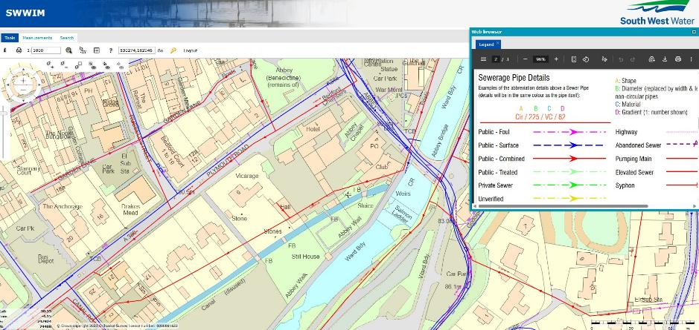
Wales & West Gas
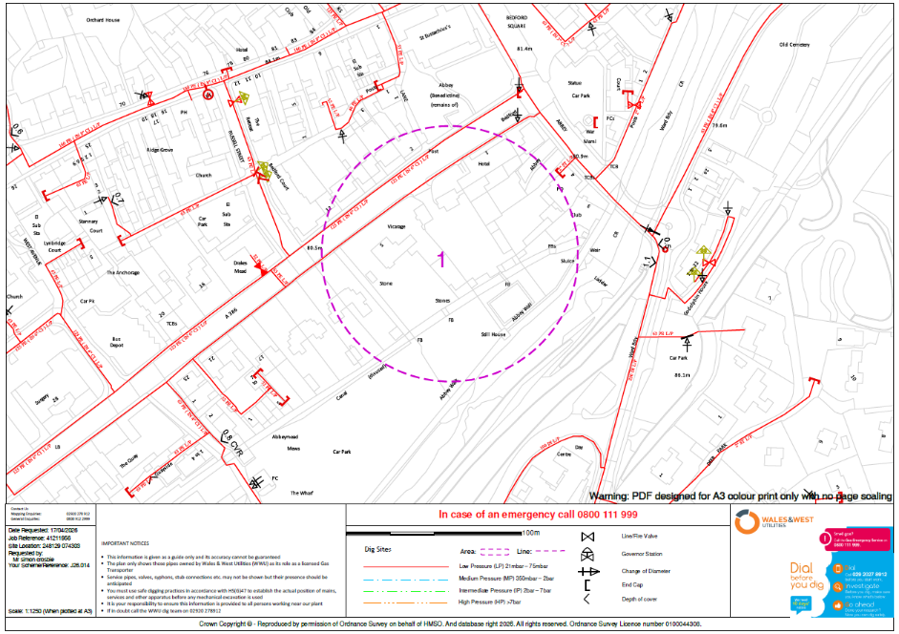

National Grid Electricity

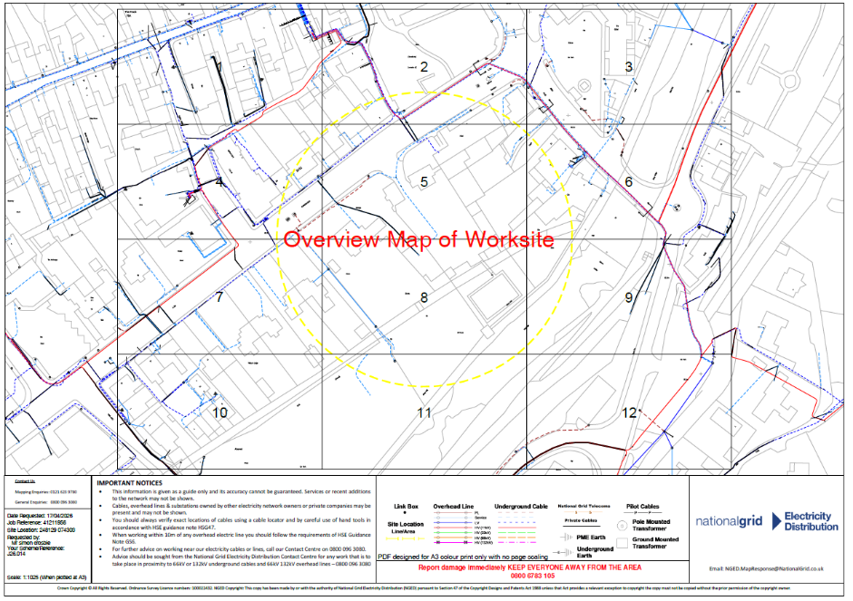

Le Page Architects Limited
Studio 2
Plumer House
Tailyour Road
Plymouth
Devon
PL6 5DH

Directors:
Simon Crosbie CIAT
Damon Pearce RIBA

T +44 (0) 1752 849880 | +44 (0) 1752 840868
www.lepagearchitects.com

Company registration No: 07204847
2 Dunheved Road Pennygillam Way Launceston
Cornwall PL15 7ED

