REDISCOVERING TAVISTOCK ABBEY
AIMS FOR ARCHAEOLOGICAL WORKS
Updated Feb 2026
- GEOPHYSICAL SURVEY
1.1 This comprises two elements - Resistivity and Magnetometry undertaken by the Project team; & Ground Penetrating Radar and any specialist techniques undertaken by contractors. GPR is essential to explore the tarred and paved areas.
1.2 To provide a comprehensive view of potential features for further study.
1.3 Where possible to interpret those features as part of a map of the Abbey
1.4 To look at the area West of the Abbey precinct for traces of tracks, canals/ditches, and buildings (This has already been largely done by volunteers, though some remains to introduce interested volunteers in Geophysical Survey)

- BUILDINGS SURVEY: PHASING
2.1 This part comprises a study of the remains of Betsy Grimbal's Tower (BGT), The Still Tower (ST), and the Abbey Cloister (AC).
2.2 Examine the extant fabric for indicators of relative (Sequences of building & repairs, mortars) or absolute age (Stonework, styles).
2.3 Construct a reasoned phase sequence for each of the 3 buildings if possible
2.4 Use these data to assist with the conservation plan going forward.

- EXCAVATIONS
3.1 The principal element of this study will be examination of the sub-surface remains of Betsy Grimbal's Tower (BGT) and the Cloister Ruin (CR). At the CR, it may also be possible to explore features shown up by the GPR survey.
3.2 To support and add to the phasing of the various buildings in the study (BGT, ST, AC)
3.3 To establish original ground levels at the time of the Abbey, prior to 19thC landfill.
3.4 To explore anomalies/features found in the Geophysical Surveys to guide future studies.
3.5 Objectives 1 & 2 will be approached through the use of small excavations within and next to the structures, focussing on corners and places where different building phases are evident above ground.
3.6 Objective 3 can be approached through evaluation trenches in areas such as the churchyard and the gardens behind the Bedford Hotel and post office. Alternately, if targets are limited, a larger area could be opened up for excavation, especially in the gardens area.

- PROJECT TEAM TASKS
4.1 The following can be supervised by experienced Project Team archaeologists assisted by volunteers and under direction of the archaeological consultant.
4.2 The Resistivity & Magnetometry of soft surface areas.
4.3 Excavation of areas in and around BGT and Cloister ruin.
4.4 Survey location of trenches and survey areas (may be included in the archaeological consultancy contract.)
4.5 Initial finds cleaning and sorting.
4.6 Excavation recording and phasing.

- EXTERNAL CONTRACTS
5.1 These will be undertaken directly by the contracted archaeological consultants with the assistance of Project Team volunteers.
5.2 GPR survey
5.3 Professional oversight, health and safety, and quality control of project team excavations.
5.4 Any GPS survey requirements
5.5 Post excavation finds and environmental work.
5.6 Provision of specialist services (sampling, conservation, spot dating etc).
5.7 Preparation of Final Report.
NB: points 2 - 6 should all be covered by a single contract with a professional archaeology unit to be chosen be y tender.

Appendix:
PROPOSED EXCAVATIONS AT BETSY GRIMBAL'S TOWER, TAVISTOCK, 2026.
6. INTRODUCTION
6.1 This document builds on previous general proposals (see above and Robey & Thompson 2025) to lay out the specific aims and justification for up to six small excavation trenches in and around Betsy Grimbal's Tower, towards applying for Scheduled Monuments Consent and producing a Brief for an Archaeological Consultant/Contractor.
6.2 The building housing the gate is a complex, multi-phased structure comprising at least three buildings: The gate passage and room over it (The 'Gatehouse' in this document); a building 4m to the north-west that might be the structure marked as a storehouse on 18th C. maps (The 'Storehouse'); and the Gatehouse extension (The 'Extension') which occupies the space between the first two, incorporating the gable end of the Storehouse and opening into both the Gatehouse and the north-western flanking tower of the gate.
6.3 It is proposed her that up to six separate small trenches be excavated inside and outside (but next to) the structure referred to here as Trenches 1 to 6 (T1-T6). The largest of these (T1) is c.5.4m² in area, two others inside are each 1.5m², and the smallest (T6) is just 0.5m². Refer to the plan for the location of these trenches.
6.4. The interior of the Gatehouse occupies approximately 22.3 m² (6.65x3.35m). The interior of the Extension (excluding the garderobe tower which is roughly 1.8m²) is 20.4m² (5.3x3.85m). The size of the Storehouse is unknown, but does not concern us here. The interior excavations thus take 29% of the Gatehouse floor, 7.1% of the Extension, and just 12.6% of the total internal area.
6.5 It was noted above that 'up to' six trenches are proposed. We believe each has a clear function and aim, and are capable of aiding our overall aims of establishing the layout date sequence, and use of the structure (Robey & Thompson 2025, Proposal for an archaeological investigation, section 4.1). Should the need arise to enlarge any of these trenches so that either the Scheduled area or the Listed structure were affected, we would seek Historic England's consent beforehand.
7. AIMS
7.1 The original aim of the archaeological component here was simply to find the medieval floor level, assuming this was one and the same as the pre19th C level-raising.
7.2 It is suggested here that this objective is only one of several important questions that archaeology could answer, some of which are of equal or greater importance to the understanding and interpretation of BGT. It is felt that we might not get the opportunity to investigate some of these for another generation, and it would therefore be remiss not to consider them at this juncture. Indeed in previous meetings that view seems to be shared by most parties on the project committee and is mentioned here only to clarify the following aims.
7.3 These aims or objectives relate to the phasing and sequence of the structures and the elements that constitute them by helping to define the relationships between the elements. The excavations may also throw light on the form (eg. floor levels) and function of the ground floor rooms.

8. OBJECTIVES BY TRENCH
8.1 T1: The main interior trench. at the western entrance to the gate, along the south-east wall. Approx 4.2 m² inside structure (1.2m² external). Intended to
8.1.1 Locate any earlier floor level/s in the gateway, particularly the level at which the spiral stair ends.
8.1.2 Locate the lower pintle of the gate.
8.1.3 Assess the nature of the surface immediately outside the gate to see whether there is a road or track leading to the gate.
8.1.4 Clarify the sequence and relationships between floor levels and the walls/foundations comp rising the gate, the passage, and the flanking stair tower.
8.2. T2: Trench (1.2m x 1.2m) at opposite end of the gate passage to investigate:
8.2.1 The relationship between the south-east and north east (precinct side) of the gate
8.2.2 The surviving early floor level/s in the passage to confirm .
8.3. T3: Trench (1.5m x 1.0m) in eastern corner of the Extension to investigate:
8.3.1. The relationship between the SE wall (NW wall of the Gatehouse) and the NE wall, some of which survives in that corner, and at foundation level.
8.3.2. The relationship of the drain to the foundations of the NE wall here.
8.3.3. The original ground level into which the foundations were cut.
8.4 T4: Trench around the external western corner of the extant structure (1.5 x 0.6m on SW side, 1.5 x 0.5m on the NW [reducing tree root damage]). Intended to
8.4.1. Examine the relationship between the gable end wall and the Extension wall at foundation level, to clarify the conflicting evidence above ground.
8.4.2. Look for any dating evidence for the Storehouse structure or the Extension.
8.4.2. Look for remains of the precinct wall beneath the NW wall.
8.5. T5: Small triangular trench (c. 0.5m²) in the angle between the SW stair tower and the precinct wall to the S. To investigate the position of the original precinct wall at this point, and its relationship to the stair tower.
8.6. T6: Small trench (0.5m x 1.0m) immediately to the West of the garderobe tower to locate the outflow drain from the garderobe.
9 SCHEDULE
9.1 Funding for these excavations is available until the Autumn of 2026. It is currently planned to carry them out in September, either after restoration on the extant walls is completed or during that work.
9.2 The intention is to run several trenches at once, depending on the availability of volunteers. In this way, it should be possible to complete the on-site work in two or three weeks.

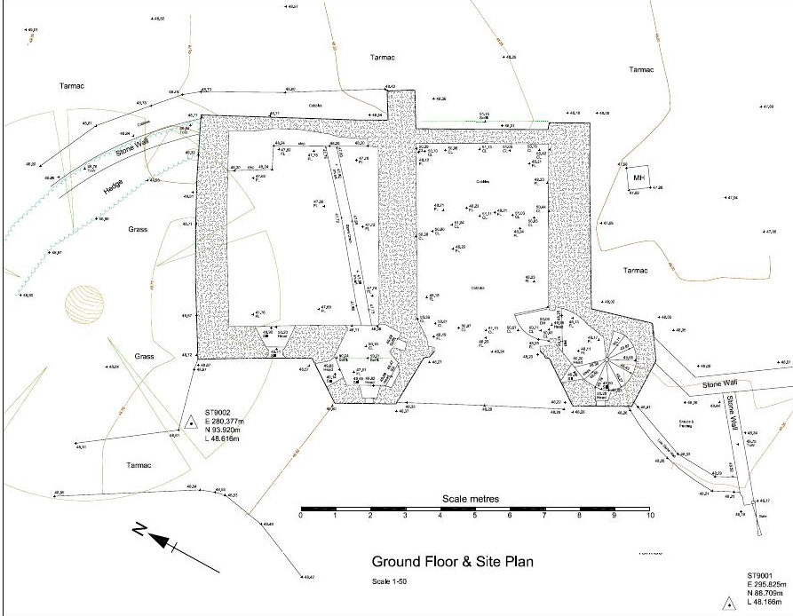

T3
T2

T4
Fig 1: Plan of BGT showing location of proposed trenches (Scale of trenches approximate)
T5
T6
T1

